ShopNest Store Capstone Project

1.Question Statement
Identify the rating distribution in the Shop_Nest dataset, showcasing ratings categorized as Excellent, Very Good, Good, Bad and Very Bad.

Visualization
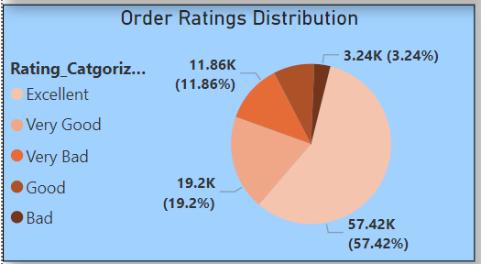

Explanation
57.42% that is more than half of the orders has got an excellent rating but almost 19.2% of our orders are rated as very good, we should focus on improving the qualities of these even further so that we can move them as well to the excellent ratings portion.
On the same side, we need to improvise our very bad and bad ratings in order to hold all of our valuable customers with us.

2.Question Statement
What are the top 10 and bottom 18 most popular product categories in the ShopNest dataset? Please list them based on the number of orders.

Visualization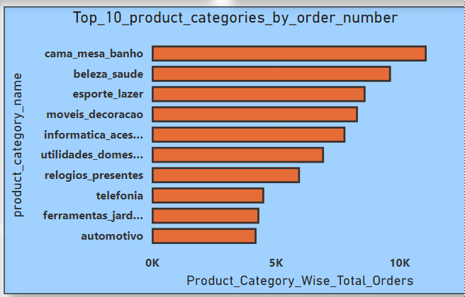
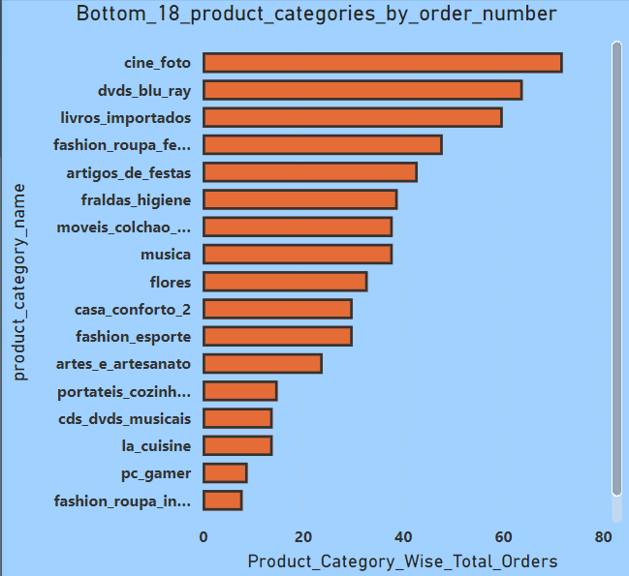

Explanation
Our top 10 product categories give a very good number of orders to ShopNest ranging almost from 5000 to more than 10000 orders. Hence, we should always keep our stocks filled more with a bulk of these product categories on the top of others.

On the order hand we should keep very less stock of the bottom 18 product categories since they lead to less than even 80 orders, even has gone below 20.

3.Question Statement
List the total number of active sellers by yearly and monthly.

Visualization
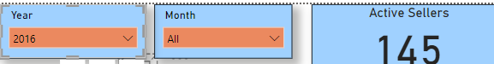
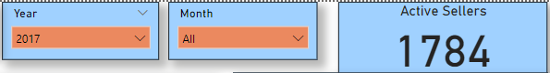
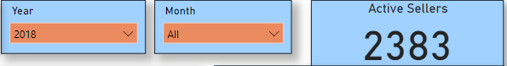

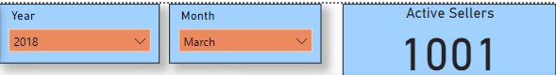
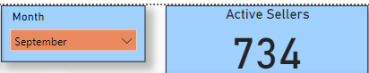

Explanation
The active sellers towards ShopNest have increased gradually from 2016 to 2018, from 145 to 2383, which resembles good growth, the sellers are showing high interests in selling through our department store.

The number of active sellers is least in the month of September that is only 734 and it is observed that active sellers are high from January to August and decreases for remaining months. Hence, we should gather products in bulk stock before the start of September and following months as a backup and should also try to gather more sellers during these months.

4.Question Statement
Which payment methods are most commonly used by ShopNest customers.

Visualization
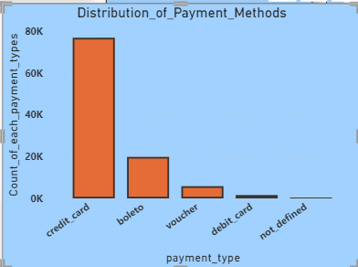

Explanation
The most frequent payment method is credit cards might be due to the rewards that we get once we shop with credit cards and also the liability, we get in terms of extra time period to make the actual payment to the bank.

5.Question Statement
Identify the product category wise profit margin using the formula
Hint:(Payment value – price +Freight_value)/payment_value*100

Visualization
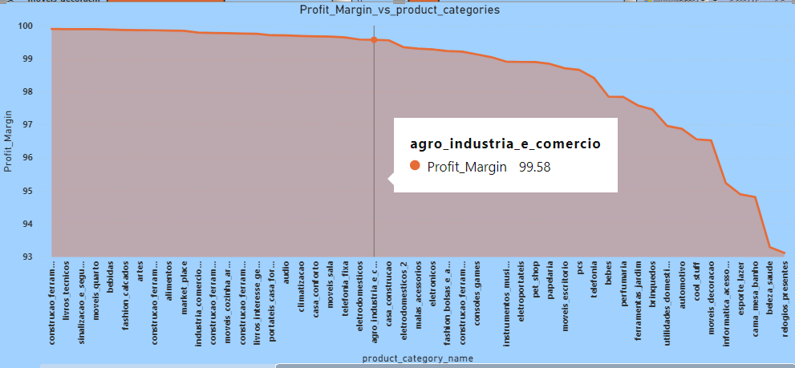

Explanation
The profit margins are 100% for most of the product categories and remained stable for most of them but from agro_industria_e_comercio product category onwards it started to drop down, hence we need to focus to increase the profit margins for these particular product categories.

6.Question Statement
Determine the monthly payments made by customers using credit cards.

Visualization
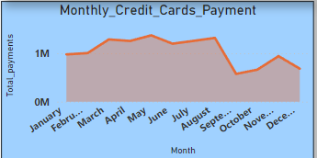

Explanation
The monthly credit cards payments are least around month of September as well as its bit lower for the months post September, while payments are higher for the month before September, it might due to less stock as we have already observed that the active sellers are less from September onwards. Hence, we have to be a bit extra careful in terms of stock in these months, also we could give some benefits to sellers who sell to ShopNest during these months, which in return would help us in gaining the attention of new sellers as well during the period.

7.Question Statement
Identify sellers categorized by city, excluding cities starting with the letters S and B.

Visualization
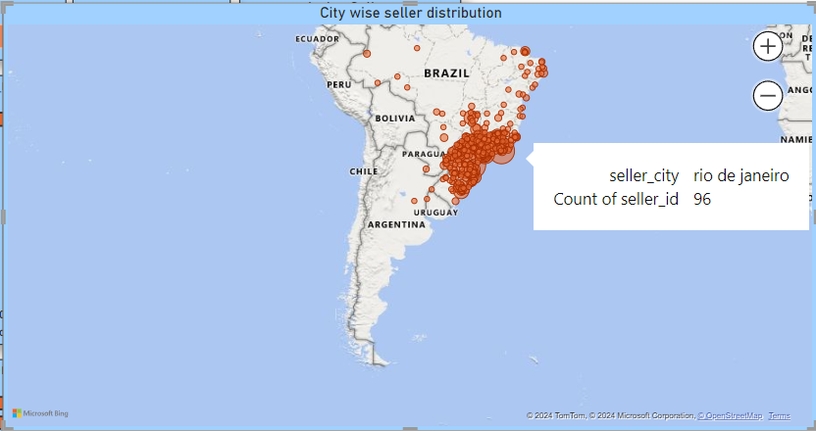

Explanation
The sellers are mostly operative in Portugal,Brazil might be due to ,ShopNest is the leading department store in Portugal itself. Hence, we should try to give some offers to gain the extra attention and investments from sellers outside Portugal as well, initially we could try to expand within the Brazil itself, later gradually we can target the areas outside Brazil as well.

8.Question Statement
Create a dynamic visual that compares the number of delayed orders to the number of orders received earlier for each month. Utilize the drill through cross-report feature to provide a detailed analysis of late and on-time deliveries.

Visualization
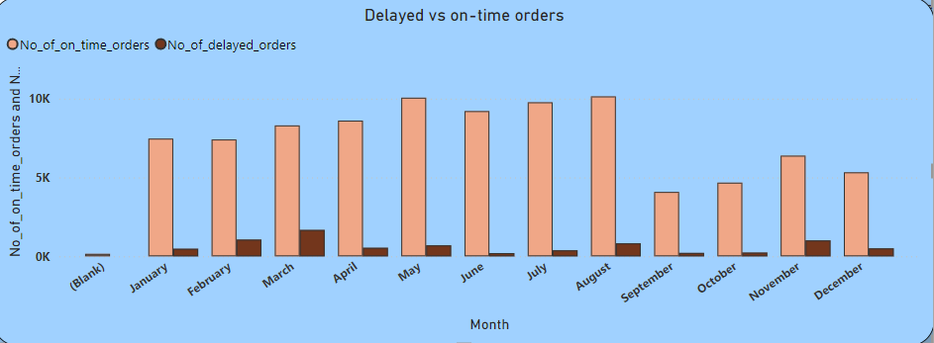
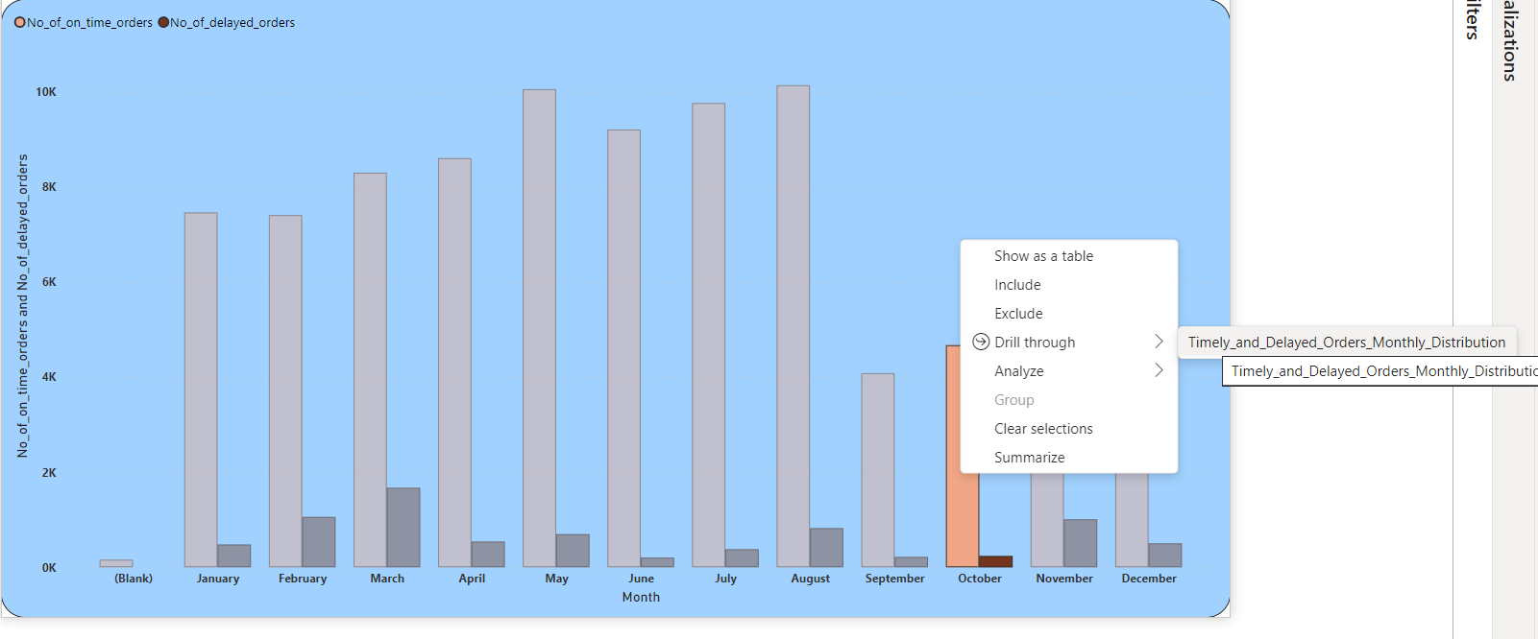
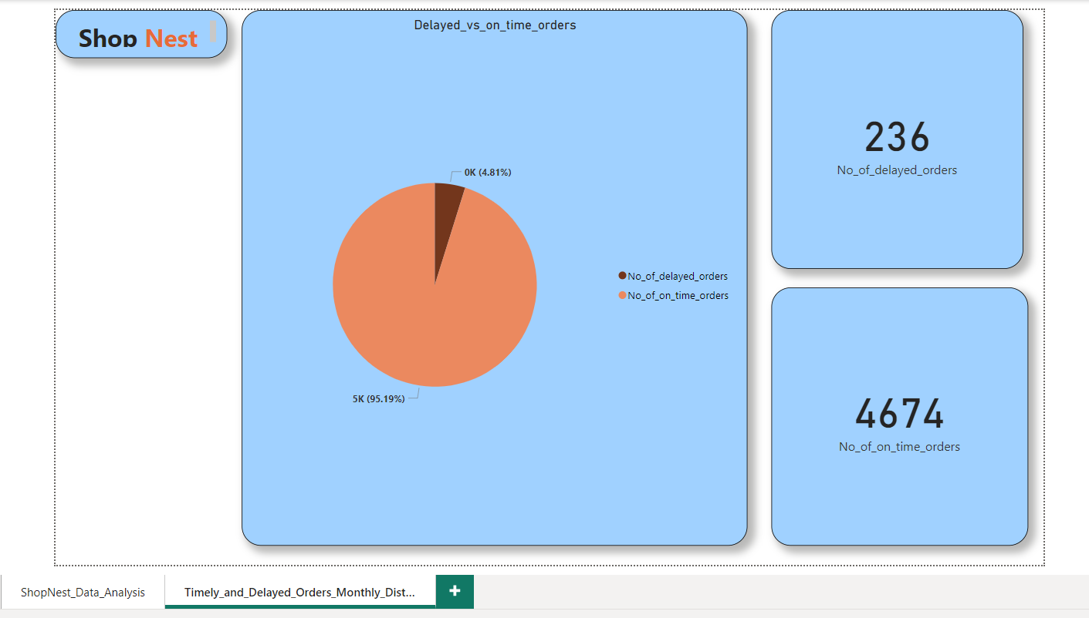

Explanation
We have seen a high number of delayed orders around the month of March, February, August and November, hence we need to improvise our logistics especially during these months.

